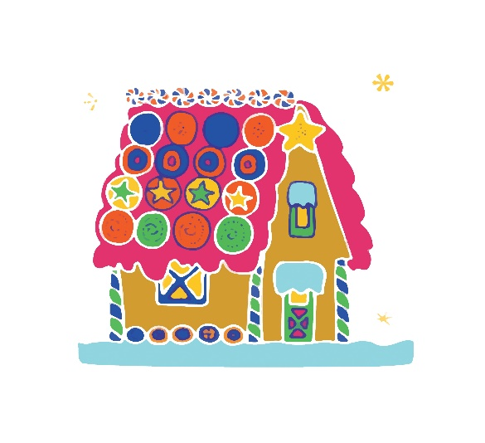


October 20, 2021

FOR IMMEDIATE RELEASE
34th Annual Holiday Cottage

(Bakersfield, CA) – On Wednesday, October 20, 2021, The Kern County Department of Human Services will officially launch our 34th Holiday Cottage through the Kern Partnership for Children and Families.

Our department would like to thank the community for their steadfast support throughout the past 33 years. Because of their generous donations, we have been able to provide thousands of Christmas gifts to local children in foster care. Our 2020 Holiday Cottage successfully granted and distributed 700 wishes through donations from our community.
As we head into the holiday season, we would like to invite the community to join us again in sponsoring a foster child’s holiday wish. Right now, we are graciously accepting donations of any amount, however $50 grants one foster child’s holiday wish. To contribute, please visit www.kernpartnership.com and click on the “GIVE HERE” button.
We are asking for your help in relaying this important message to the public. The media plays a vital role in making sure our message is heard loud and clear. With your help, we will continue our efforts to ensure that children in Kern County Foster Care receive a gift through the Holiday Cottage. During December, we will distribute the purchased gifts to children in Kern County foster care.

Thank you so much for supporting the 34th annual Holiday Cottage.

For media arrangements, please contact Jana Slagle at 661.342.8054 or Alison Votaw at 661.428-0471.

# # #

