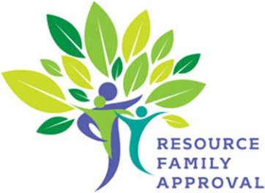
Step 1
Complete an RFA Orientation Online
https://www.kcdhs.org/services/resource-foster-families/orientation-training/orientation-online
Or
Register at (661) 631-6204 to attend a class

Step 2*
Receive your online e-Adopt temporary password to log-in, create your profile
and begin the application process.

Step 5*
Complete family interviews and a family evaluation to receive your final report of approval. Your RFA social worker will review your final report with you.
An approved Resource Family may take placement of a child in their home.

Step 4*
Schedule a home and grounds inspection. Your RFA social worker will call you to discuss what to expect and how to prepare.
*Step 2 - Call (661) 873-2800 to ask for the RFA worker of the day, or visit the Columbus Center at 3711 Columbus Street if you need help, have questions, or want to use a computer to access your online e-Adopt account during normal business hours: 7:30 am – 4:00 pm.

*Step 3 – Things to do as part of the application process:
- Live Scan (fingerprint) all adults in the home and those adults who are regularly present. Call (661) 631-6879 to schedule appointments.
- Request criminal record exemption as needed. Forms are on e-Adopt or call your RFA social worker.
- Complete the Health Questionnaire form and your RFA Social Worker will asses to determine whether further medical health clearance is needed by a licensed health care professional.
- CPR/First Aid certification. Call (661) 319-1836 to register.
- Attend Pre-Service Training. Call (661) 395-4991 to register.

PLEASE NOTE: Being an approved Resource Family does not guarantee a child will be placed in your home. A child’s social worker must consider the best interests of the child before placing a child in a home.
5 STEPS TO COMPLETE RESOURCE FAMILY APPROVAL APPLICATION PROCESS
Step 3*
Continue the online application process by completing all of the health and safety clearances for family home approval.

