Audience / Role | Employee
Description | This job aid provides instructions to get started with Workday including Navigation, Search, and My Task.
Before You Start | Ensure all login and credentialling has been established.

Navigate the Home Page
The Workday Home page has a link labeled View All Apps that displays applications and shortcuts in the Global Navigation menu, providing access to tasks and reports. The Home page is highly configurable, so your organization may display different applications.

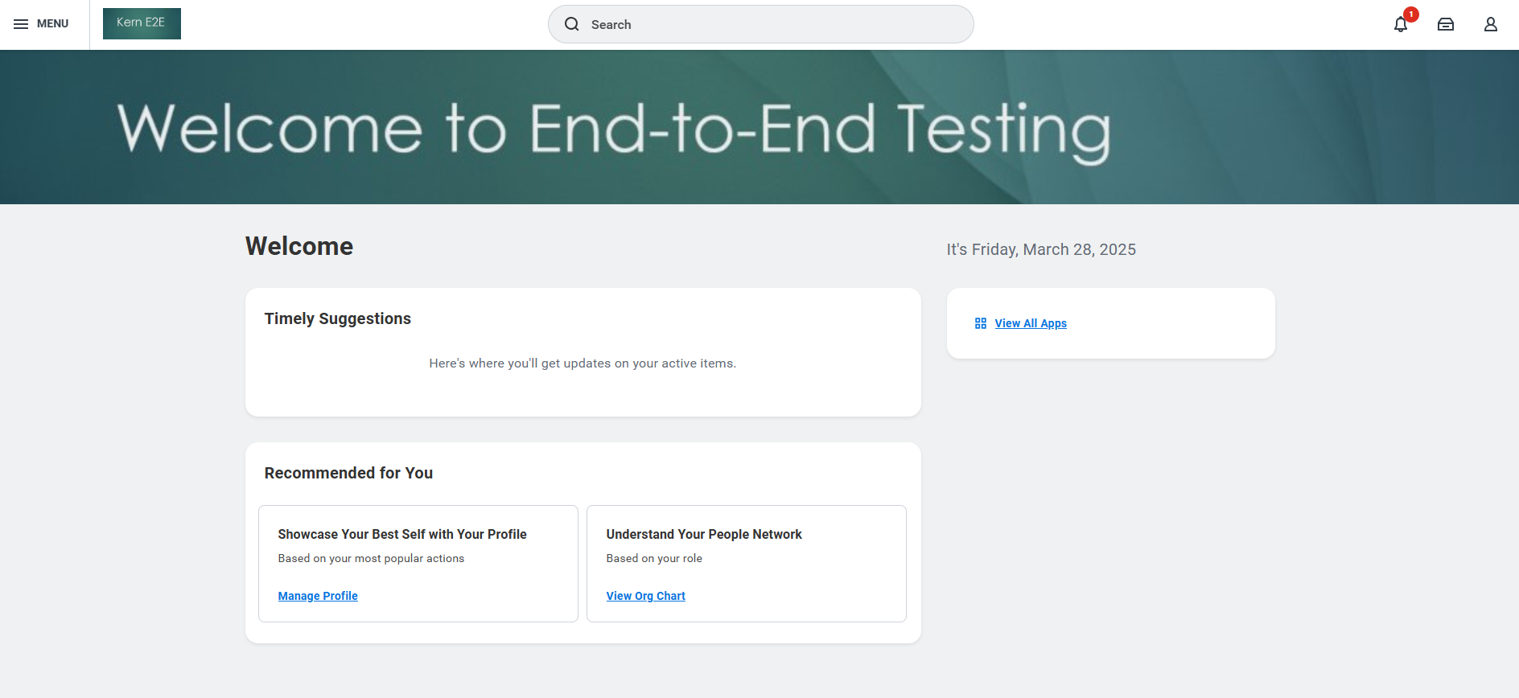

Configure Applications
1 | In the upper-left hand corner, select the MENU icon. The Global Navigation Menu displays.
2 | Select the Sort icon to sort your applications by Your Saved Order, Recently Used, or Frequently Used.
3 | Select the Add icon to search for and add an application.
4 | Select the Edit icon to edit the list of existing applications.
5 | In the Edit Apps menu, select the Remove icon to remove an application.
6 | Select the Move Buttons icon to reorder the applications.
7 | Select Save Changes.

Application Layout
Review the application layout. Buttons in the Actions section link to tasks you can perform. Buttons in the View section link to reports you can view as shown in the example image.
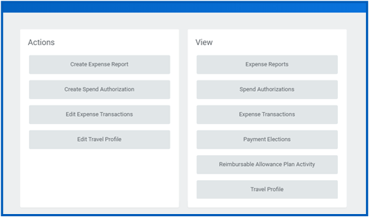

Error and Alert Messages
Error and alert messages typically identify specific fields where information is missing, entered incorrectly, or in conflict with a rule established by your organization. Select the notification to view the error details.
Errors display in red and note the number of identified errors as shown in the example images below. You cannot complete a task until you correct all errors.

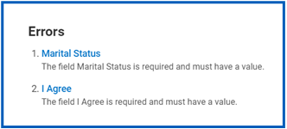
Alerts display in orange and note the number of alerts as shown in the example images below. Alerts notify you of potential problems on a page, but do not prevent you from completing the task. Select the alert notification to view the location of missing or problematic information within the task, report, or business process.

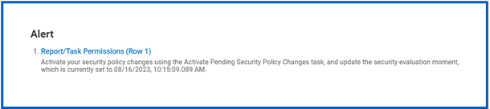

Related Actions and the Profile Menu
At this time your profile is fairly limited. The profile menu contains links to the Home page, My Account, and Favorites, among others. You can also access Workday documentation by selecting the Documentation link. You can open the Profile menu by selecting your Profile photo as shown in the example below.
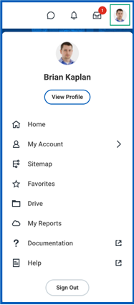
Related Actions display next to an object. You can use them to access relevant actions. For example, the Related Actions icon next to your name accesses tasks, reports, and data related to your worker record (e.g., viewing or changing your benefits). In Workday, there are multiple ways to navigate to the same task, report, or data. For example, most actions available through Related Actions are also available through applications or the Search box.
The following are three common types of Related Actions:
- Related Actions may appear when hovering your cursor next to a business object or link as shown in the image below.
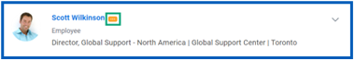
- In your worker profile header, you can access your Related Actions from the Actions button under your name as shown in the example below.
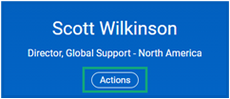
- Similarly, you can find Related Actions in task and report headers as shown in the following example.
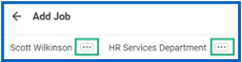

Change Your Account Settings
1 | Select your Profile photo.
2 | Select My Account.
3 | From here, you can access your organization ID, change your password, change your public profile preferences, manage your password challenge questions, and view sign-in history

Guided Tours
Product tours provide contextual and informative text to guide you through a task with field-level tool tips. This tenanted text is only available for certain tasks and may vary depending on your organization’s configuration.
To activate a product tour, select the question mark in the top-right corner as shown in the following example.
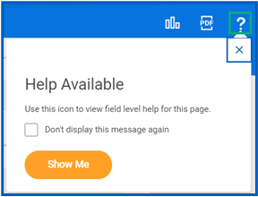
Question marks appear next to fields configured with help text to clarify the type of data required as shown in the image.
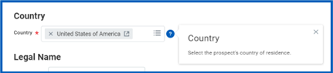

SEARCH

Global Search
Workday makes it easy to search for people, tasks, reports, and business data using the Search box.
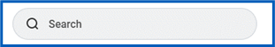
For example, to find a worker, enter their name into the Search box, and then press Enter on your keyboard. From the search results, navigate to the Categories list and select People to filter the results to only display workers in your organization. Use search categories to filter your search for more specific results.
Exact Match
Keep in mind that searches find exact matches. If you misspell the search text, likely no results will return. Workday Search also favors complete word matches over partial word matches, so that search results match the term you enter more closely. If you search using partial names or terms, the results may not display partial matches, depending on data volume. For example, if you search for “Alex,” the results may not display the name “Alexander.”
Partial Search
Though complete word matches are favorable, you can also use a partial search to find your results. For example, if you want to find the Maintain Candidate List Assignment task, you can use the search string “main can lis”. Though this method is still effective, it may not be a best practice for all search types where Workday returns multiple results.
Prefixes
Search prefixes restrict the search results to a particular type of Workday object. Search prefixes are lowercase letters, followed by a colon (:). For example, “bp:” returns all business process definitions. To return a list of all search prefixes available to you, enter a question mark (?) in the Search box and then press Enter.
Auto-Suggest
Global Search Auto-Suggest displays suggested results as the first type-ahead result. It also displays loading animations when type-ahead is fetching results. To view all results, select the View More button on the search results page, as shown in the image below.
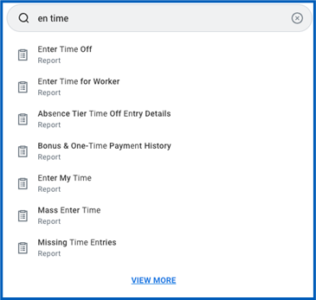
Recent Searches
Workday saves your recent search results and queries for convenience. The five most recent searches display, helping you access these items faster. You can clear the results by selecting Clear in the Search box pull-down.
Search Categories
Workday enables you to use categories to search for specific items and filter results, reducing the number of out-of-context search results. If a user does not have security access to a particular category, Workday will not list the category in the Search box pull-down. Also, the search categories are not configurable. Selecting a category adds the option to the Search box as a search criterion. This added search criteria filters search results, as shown in the image below.
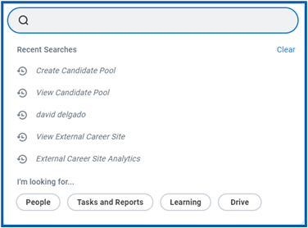

Worker Search
You can quickly find an active worker in global search, reports, and prompts. From the Search box, you can search for a worker by first name only. Workday sorts the results by relevance, first showing all workers with a matching first name.
After searching for a worker, their photo, business title, supervisory organization, and location display. This identifying information makes it easy to confirm you have found the correct person, as shown in the image below.
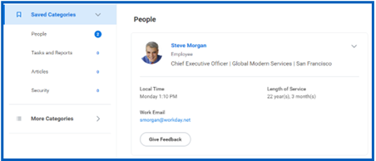

Prompt Search
With prompt search, you can search directly in a prompt, as shown in the image below.
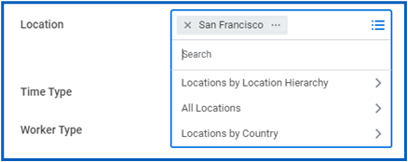
There are two ways to use this search type:
- Use the hierarchy provided in the prompt until you find what you are looking for.
- Enter a search term and the system searches against the data that is applicable to that selection.
To make your search most effective:
- Use specific searches, like global search.
- Avoid general terms such as “find” and “work.”
- Search for custom IDs, available to power users, for the quickest results.
- Use the first two letters to jump directly to the results and then press Enter on your keyboard. Selecting anywhere outside of the prompt deletes the search.

Search Reports-There are two main cases for using Search Reports:
1 | Filter Use Case  Use the filter functionality when you want to find something manually. For example, if you are searching for a specific inventory item, you can use the filter to narrow the search by manufacturer. Then, filter by part type to further reduce results, as shown in the image below.  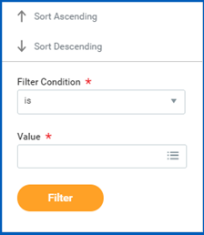
2 | Search Use Case  If you only have a general idea of what you are looking for, use Find reports to help you narrow down your search. For example, if you are looking to fill an open position with someone internally and they need to meet specific criteria, use the Find Workers report. You can search for employees by city, skillset, cost center, and so on. You can also use the search field within the report to tailor your search results using different types of search methods.  These include:  - Boolean search – (sales OR marketing) AND manager  - Phrase search – “marketing manager”  - Exact Match – specificmail@workday.com  You can save faceted searches for later use, as shown in the image below.  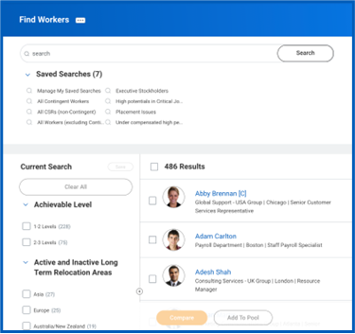  From the search results, select a link for more information or initiate an action from the object’s Related Actions.

Use Your My Tasks
View Your My Tasks
1 | Near your Profile photo, select the My Tasks icon.
2 | Choose the All Items tab to view your business process tasks, approvals, and to-dos.
3 | Choose the Saved Searches tab to display all the saved searches you have created via Advanced Search
4 | Choose the Filters tab to view a category of items such as Overdue, Absence/Time, and Expense Report Approvals.
5 | Choose the Archive tab to access the status of your previous business processes.
6 | If applicable, the Bulk Approve and Manage Delegations tabs will also be visible in your My Tasks section.
 | 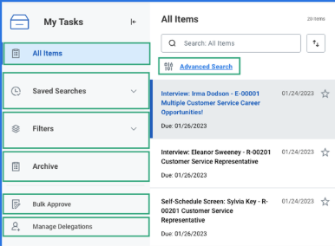

My Task Features
1 | The My Tasks navigational panel is collapsible, allowing for more screen real estate to complete your tasks.
2 | The sorting option allows you to sort your My Tasks items by Newest on Top, Oldest on Top, and Due Soonest on Top.
3 | From the sorting option, select your display density by either choosing Simple or Detailed. Detailed provides more information to identify which tasks need your attention.  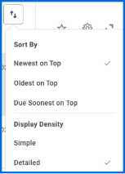
4 | Mark an item as a favorite and it will display in your Favorites filter.
5 | Use the search functionality on the All Items and Archive tabs to find a specific task.

Delegate my In Box
1 | Workday allows you to delegate your My Tasks items to a colleague. This is useful if you are unable to perform the actions yourself when you are away.  On the My Delegations page, select Manage Delegations.
2 | Enter the begin date and end date for the delegation.
3 | In the Delegate field, select a user to delegate your tasks to.  Note: If you are only delegating Inbox tasks, leave the Start On My Behalf field blank. This option is for delegating the initiation of business processes.
4 | In the Do Inbox Tasks On My Behalf field, select whether to delegate all business processes, specific business processes, or none of the above.
5 | Select the Retain Access to Delegated Tasks within My Tasks checkbox to view and modify your My Tasks while delegated.
6 | Select Submit.
7 | Optional) From the pop-up, select View Details to view the confirmation page. Depending on the security settings, your organization may require additional approvals.  Note: From your My Delegations page, select the Business Processes Allowed for Delegation tab to view which business processes you can delegate.

