Kern County Independent Living Program (ILP) Unit
The Dream Center at 1801 19th Street (661) 636-4488
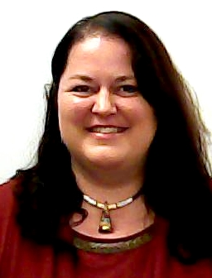 Johannah Isaacs Program Specialist isaacsj@kerndhs.com 636-4965
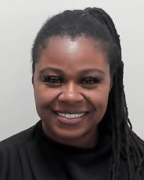 ILP/ AB-12 Work Cell (661) 556-0349
Robin Chambers ILP Supervisor chamber@kerndhs.com (661) 636-4971
 Unit 2580 Cell (661) 556-0293
Andrea Martinez, ILP Social Worker martina@kerndhs.com (661) 636-4987
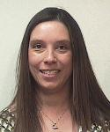 Case Load 2581 (661) 617-7976
Tamara Roberts, ILP Social Worker robertta@kerndhs.com (661) 636-4944
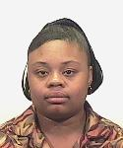 Case Load 2588 Cell (661) 556-0437
Keith Hollins, ILP Social Worker hollink@kerndhs.com (661) 636-4982
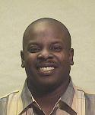 Case Load 2585 (661) Cell 556-0292
Maria Escalante, ILP Social Worker escalam@kerndhs.com (661) 636-4954
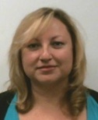 Case Load 2586 Cell (661) 556-0436
Wulfrano Zamora, ILP Social Worker zamorw@kerndhs.com 636-4995
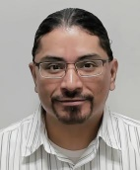 Case Load 2589 Cell (661) 531-6827

Robin Bramlett, Traveling Social Worker South bramler@kerndhs.com 631-6766
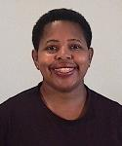 Case Load 2582 Cell (661) 556-0497
Ytzayana Sarmiento,Human Serivce Aid sarmiesy@kerndhs.com
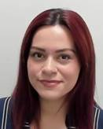 Case Load 2587 Cell (661) 531-6804

PAYROLL DIRECT PHONE NUMBERS
A-D – Tiffany Alvarado, 661-633-7371; alvarat@kerndhs.com
E-L – Bayleigh Humes, 661-633-7370; humesb@kerndhs.com
M-R – Jessica Lidgett 661-633-7391; lidgetj@kerndhs.com
S-Z – Victoria Villatoro, 661-633-7384; villatv@kerndhs.com
Megan Pittman, Payroll AC661-633-7372 pittmame@kerndhs.com
DHSPayroll@kerndhs.com

Help Desk: 633-7297 ER Phone Room: 661-631-6011 FAX
ILP Trust Fund: http://web0/FiscalFundManager/Report.aspx
Rocio Solis Adoption Assistance Program 873-2842
Maria Granados Fiscal 633-7310

ILP/ AB-12 Support Staff in Bea Toro’s Unit
Shanteria Lee, Office Service Technician leeshan@kerndhs.com 636-4953
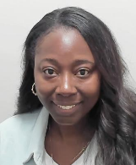 Case Load 2411 Cell (661) 428-0393
Delilah Sanchez, Traveling Social Worker North sanchede@kerndhs.com 631-6322
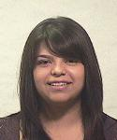 Case Load 2418 Cell (661) 858-8953

Cassandra Flores. AB-12 Intern florezc@kerndhs.com 636-4994
Case Load 2419 Cell (661) 451-8276

Extended Foster Care AB-12 Unit at the Dream Center

Beatriz Toro AB-12 Supervisor torob@kerndhs.com (661) 636-4970
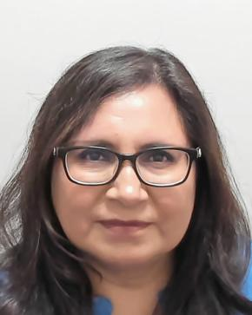 Case Load 2410 Cell (661) 556-0414
Francisco Martinez, AB-12 Social Worker martinf@kerndhs.com 636-4946
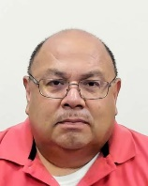 Case Load 2416 Cell (661) 556-0503
Virginia Sanchez. AB-12 Social Worker sanchevi@kerndhs.com 636-4974
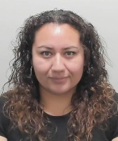 Case Load 2415 Cell (661) 903-4893

Sonia Salas, AB-12 Social Worker soliss@kerndhs.com 636-4922
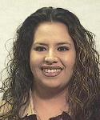 Case Load 2413 Cell (661) 556-0373

Alberto Arteaga. AB-12 Social Worker arteaga@kerndhs.com 636-4973
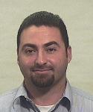 Case Load 2412 Cell (661) 556-0275
Lorena Altamirano. AB-12 Social Worker altamil@kerndhs.com 636-4998
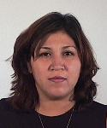 Case Load 2414 Cell (661) 654-1951
Somphou Siripane. AB-12 Social Worker siripans@kerndhs.com 636-4974
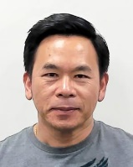 Case Load 2417 Cell (661) 556-0444

