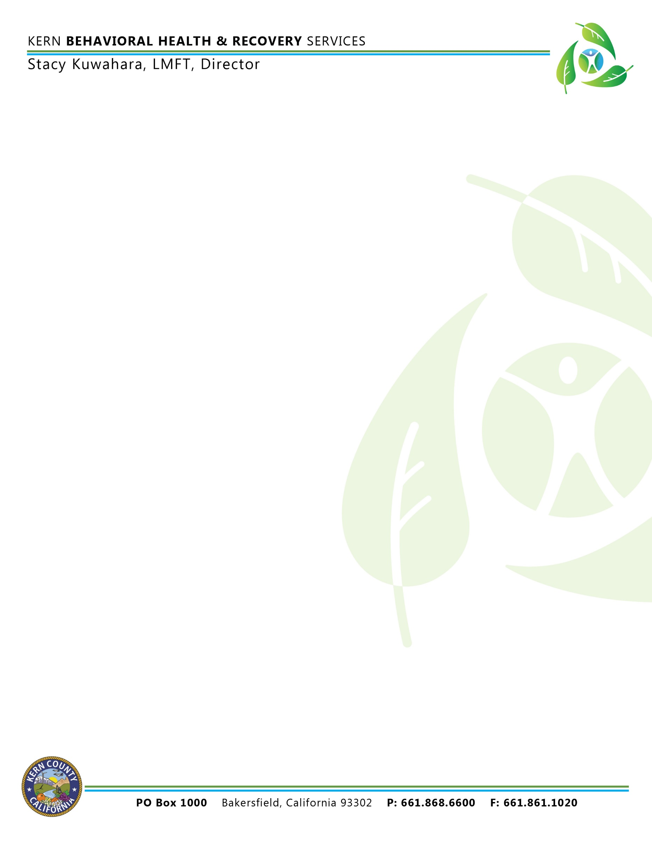

GRIEVANCE AND APPEAL PROCESS
You have a right to make a grievance about any aspect of your treatment at a clinic or by a Medi-Cal “Fee-for-Service” Provider (Private psychiatrist, psychologist, LCSW or LMFT). You also have the right to appeal an “Adverse Benefit Determination” as taken by the County’s Mental Health Plan and Drug Medi-Cal Organized Delivery System (see below for “Adverse Benefit Determination” definition).
- You may make a Grievance or Appeal verbally or in writing. Standard grievance resolutions will be made within 90 calendar days of receipt of a grievance. Standard Appeals will be resolved within 30 calendar days of receipt of the appeal. Expedited appeals will be resolved no longer than 72 hours from the date and time of the expedited appeal receipt.
- These timeframes may be extended by up to 14 calendar days if you request an extension or if the Mental Health Plan determines that there is a need for additional information and that the delay is in your best interest.
- Grievance Forms and Appeal Forms are available in the waiting room of the clinic, or the “Fee-for-Service” Provider.
- You may use an authorized representative on your behalf.
- Expedited Appeals may be requested if the beneficiary or the beneficiary’s provider certifies that taking the time for a standard Appeal resolution could seriously jeopardize the beneficiary’s life, health or ability to attain, maintain, or regain maximum function.
- You may verbally, or in writing, file for a State Fair hearing, after the exhaustion of an Action Appeal or Expedited Action Appeal process, whether or not, you have received a Notice of Action.

An “Adverse Benefit Determination” is defined as:
- Denial, or limiting of an authorization of a requested service, including the type or level of service;
- Reducing, suspending, or terminating a previously authorized service;
- Denial, in whole or in part, of payment for a service;
- Failing to provide services in a timely manner, as determined by the Mental Health Plan or;
- Failing to act within the required timeframes for standard resolution of grievances and appeals, or the resolution of expedited Action Appeals.
Please note: The County’s Grievance and Appeal System, must be exhausted, prior to the requesting of a State Fair Hearing. It is intended to resolve problems in the most prompt, efficient and effective manner possible. If you have any questions, call the Patients’ Rights Office at 1(844) 360-8250
Beneficiary Grievance and Appeal Rights:
- To be treated with dignity and respect
- To file a Grievance or Appeal verbally or in writing in the primary or preferred language
- To ask for assistance with the Grievance and Appeal process
- To authorize another person to act on his/her behalf
- To identify a staff person or other individual to assist with the Grievance and Appeal process
- To identify a staff person or other individual to provide information regarding Grievance process status
- To not be subject to discrimination or any other penalty for filing a Grievance
- To select a provider as his/her representative in the Appeal process
- To continue receiving services while an Appeal is pending

